What are VM
- Stands for Virtual Machine
- Software based computer that runs inside a physical computer
- It has own OS, CPU, RAM, storage and applications
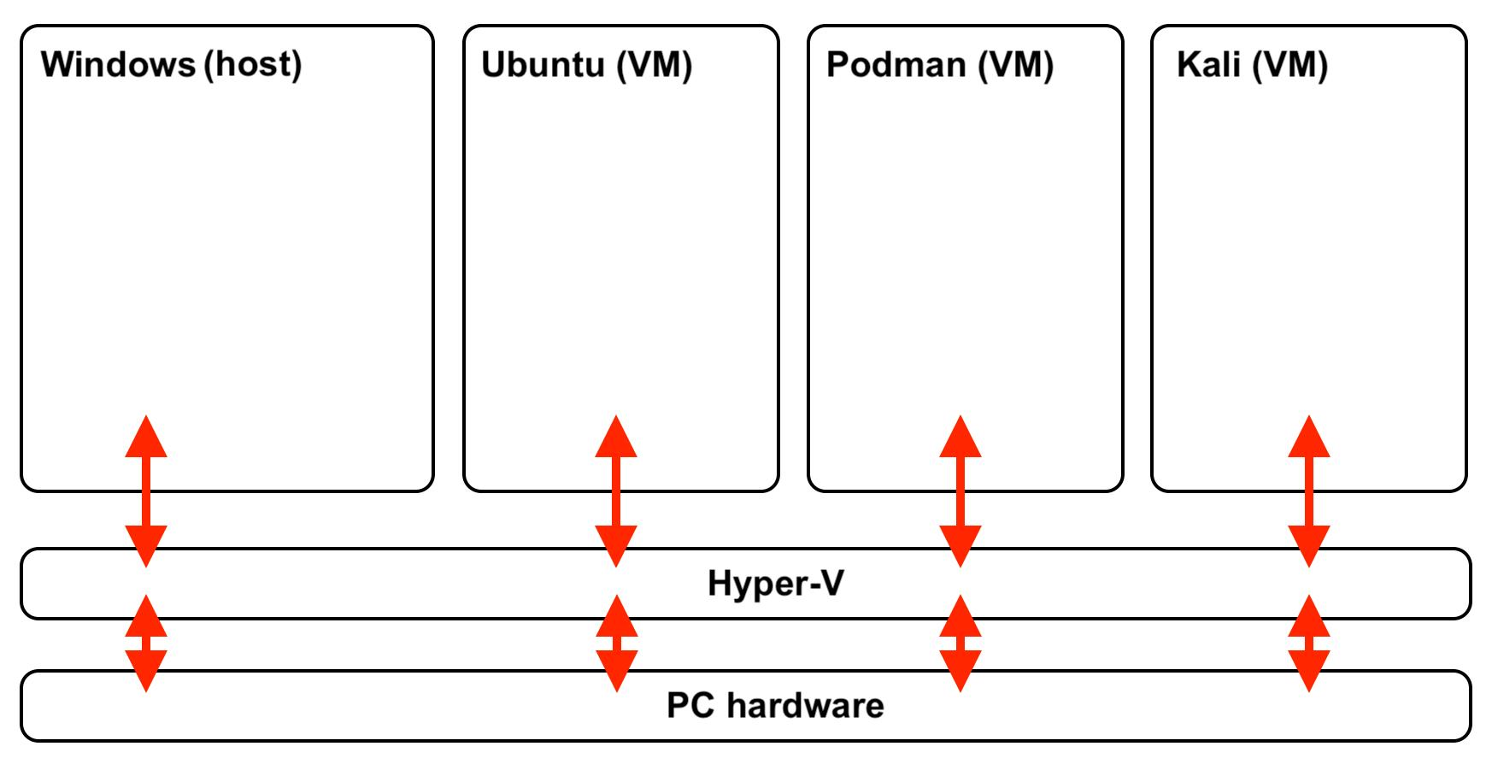
- One physical computer can have many virtual computers inside through virtualization. And each computer is called Virtual Machine.

PC Hardware – Physical computer
Hypervisor – Software that creates and manage virtual machine

Components of an Azure Virtual Machine (VM)
An Azure Virtual Machine consists of several components that work together to create and run a virtual computer in Microsoft Azure.
- CPU
Perform calculations and execute instruction
Determine processing power of VM
Azure allows select VM size with different CPU capacities
- RAM
Temporary storage while running the program
RAM cleared when VM stopped and deallocated
3.Storage
Store OS, App and data
3 main disk type
OS Disk – contain OS
Data Disk – store data and file
Temporary Disk – Temporary storage
4.OS
Software that manages VM
Example: Windows Server
5.Networking
Helps in communicating with the internet and other system
Important networking components:
- Virtual Network (VNet)
- Network Interface Card (NIC)
- Public IP Address
- Private IP Address
- Network Security Group (NSG)
6.Security
Protects the VM from unauthorized access.
Examples:
- Username and password / SSH keys
- Network Security Groups
- Azure security services
Component | Main purpose
CPU | Processing
RAM | Temporary memory
OS Disk | Operating system storage
Data Disk | Additional data storage
VNet | Network communication
NIC | Connects VM to network
Public IP | Internet-facing access
Private IP | Internal network communication
NSG | Controls network traffic

